Supporting information for

Lateral confinement in 2D nanoplatelets: a strategy to expand the colloidal quantum engineering toolbox

Leonardo Curti^{1$}, Corentin Dabard^{1$}, Lina Makké¹, Ningyuan Fu¹, Henri Lehouelleur¹, Muchuan Hua², Erwan Bossavit^{3,4}, Mariarosa Cavallo⁴, Xiang Zhen Xu¹, Debora Pierucci⁴, Mathieu G. Silly³, Burak Guzelturk⁵, Emmanuel Lhuillier⁴, Juan I Climente⁶, Benjamin T. Diroll², Sandrine Ithurria^{1*}

¹ Laboratoire de Physique et d’Etude des Matériaux, ESPCI, PSL Research University, Sorbonne Université, CNRS, 10 rue Vauquelin, 75005 Paris, France.
² Center for Nanoscale Materials, Argonne National Laboratory, 9700 S. Cass Avenue, Lemont, Illinois 60439, United States
³ Synchrotron SOLEIL, L'Orme des Merisiers, Départementale 128, 91190 Saint-Aubin, France.
⁴Sorbonne Université, CNRS, Institut des NanoSciences de Paris, 4 place jussieu, 75005 Paris, France
⁵X-Ray Sciences Division, Argonne National Laboratory, 9700 S. Cass Avenue, Lemont, Illinois 60439, United States
⁶ Departament de Quimica Fisica i Analitica, Universitat Jaume I, E-12080, Castello de la Plana, Spain.

*To whom correspondence should be sent: Sandrine.ithurria@espci.fr

Table of content
1. Core crown-crown-shell NPLs 2
2. Chemical analysis of the core-crown-crown-shell NPLs 3
3. Hole wavefunction in laterally confined C-C-C-S NPLs. 5
4. Luminescence from core-crown-crown-shell NPLs 6
5. LED stack band diagram 7
6. Thermal dependence for PL of core-crown-crown-shell NPLs 8
7. REFERENCES 8

Core crown-crown-shell NPLs

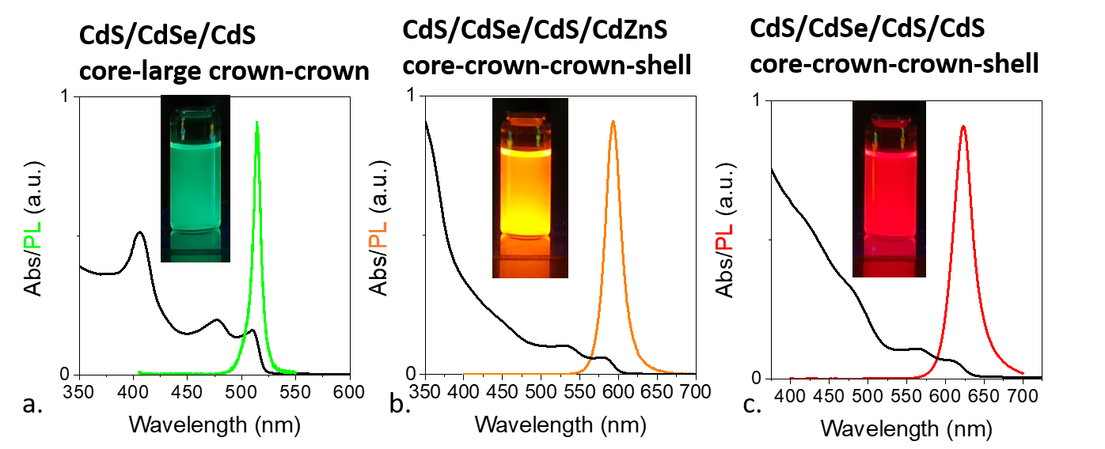
Figure S 1 Synthesis of weakly laterally confined core-large crown-crown-shell NPLs. a. Absorbance and photoluminescence spectra of CdS/CdSe/CdS core-large crown-crown NPLs. Inset is an image of the solution under UV illumination. b. Absorbance and photoluminescence spectra of CdS/CdSe/CdS/CdZnS core-large crown-crown-shell NPLs. Inset is an image of the solution under UV illumination. c. Absorbance and photoluminescence spectra of CdS/CdSe/CdS/CdS core-large crown-crown-shell NPLs. Inset is an image of the solution under UV illumination.

Table S 1 Luminescence properties of the material depicted in Figure 1.
Heterostructure | PL max (nm) | FWHM (nm) | PLQY (%)
CdS core | 418 | 12 | 12 ±2
CdS/CdSe core crown | 497 | 18 | 24 ±3
CdS/CdSe/CdS C-C-C | 502 | 15 | 55 ±8
CdS/CdSe/CdS/CdZnS C-C-C-S | 575 | 37 | 68 ±5

Chemical analysis of the core-crown-crown-shell NPLs
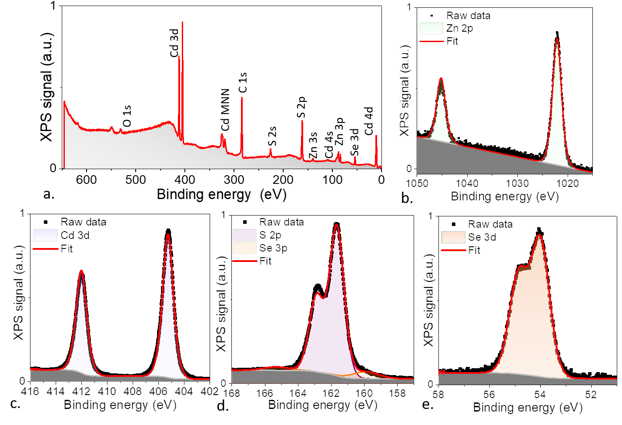
Figure S 2 Photoemission spectroscopy laterally confined C-C-C-S NPLs (material from figure 1). Survey photoemission spectrum acquired with a 700 eV photon energy. b. Zn 2p core level acquired at 1150 eV as photon energy. c. Cd 3d core level acquired with a 700 eV photon energy. d. S 2p (and Se 3p) core levels acquired with a 700 eV photon energy. e. Se 3d core level acquired at 700 eV as photon energy.
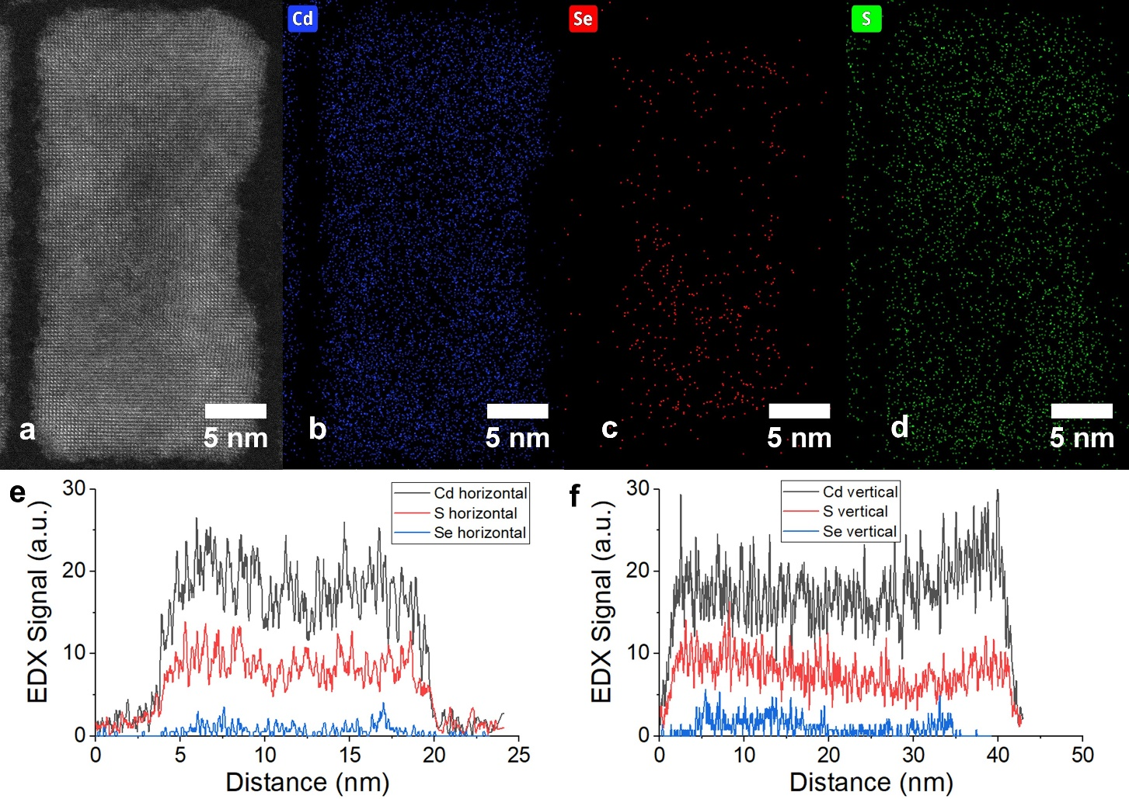
Figure S 3 Chemical mapping for CdS/CdSe/CdS/CdS C-C-C-S NPLs. (a). STEM HAADF for the core-crown-crown-shell NPLs. Elemental maps of (b) Cd, (c) Se, and (d) S. (e) and (f) are line-scans in the (e) horizontal and (f) vertical directions across the image of the plate as shown.

Hole wavefunction in laterally confined C-C-C-S NPLs.
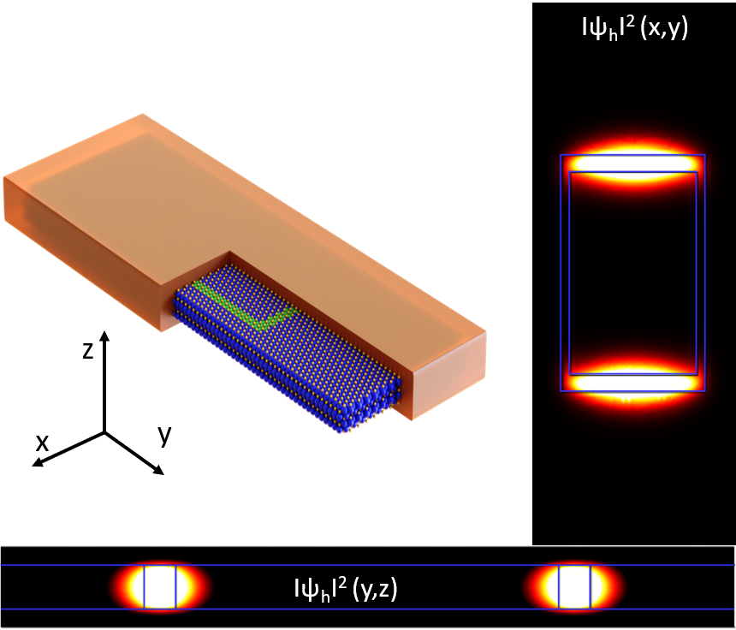
Figure S 4 hole wavefunction. Schematic of the CdS/CdSe/CdS/ZnS C-C-C-S NPL and hole density within the lateral extension (x,y plane) and the thickness (y,z plane).

Luminescence from core-crown-crown-shell NPLs

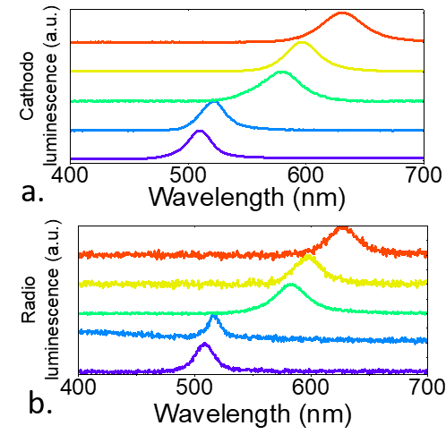
Figure S 5 Luminescence from CdS/CdSe/CdS C-C-C NPLs and their shelled counterparts. a. Cathodoluminescence spectra for CdS/CdSe/CdS C-C-C NPLs with a narrow (1 nm) CdSe crown (purple), for CdS/CdSe/CdS C-C-C NPLs with a large (3 nm) CdSe crown (blue), for CdS/CdSe/CdS/CdZnS C-C-C-S NPLs with a narrow (1 nm) CdSe crown (green), for CdS/CdSe/CdS/CdZnS C-C-C-S NPLs with a large (3 nm) CdSe crown (yellow), for CdS/CdSe/CdS/CdS C-C-C-S NPLs with a large (3 nm) CdSe crown (red). b. Radioluminescence spectra for the same set of samples as a.

LED stack band diagram
The energy diagram of the LED stack proposed by Dai et al¹ initially was determined previously for CdSe/ZnS NPLs.² Here we update this diagram to account for actual band gap. Work function is assumed to be unchanged given both NPL have similar surface chemistry (i.e., same surface dipole).
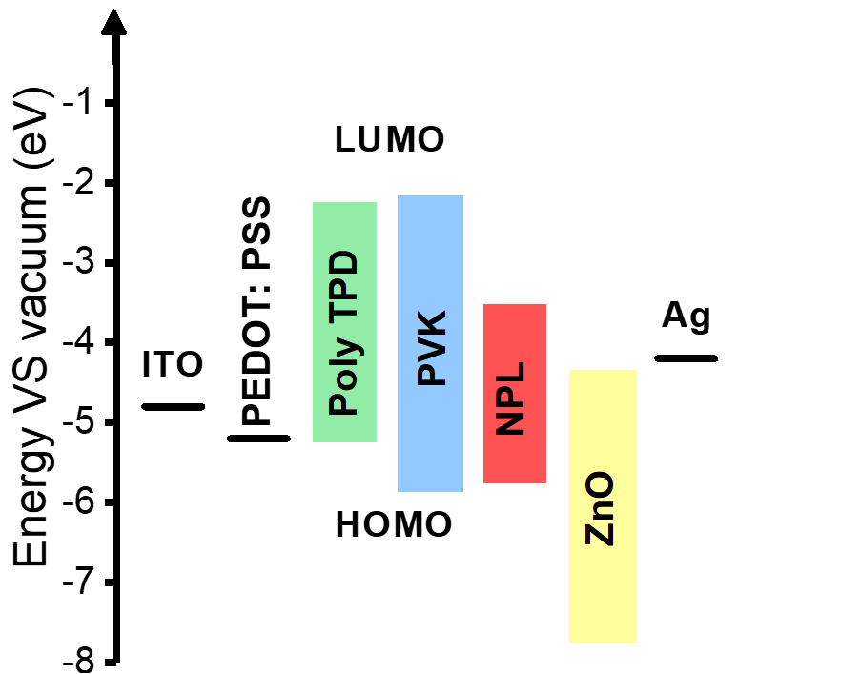
Figure S 6 Energy alignment for the LED.

Thermal dependence for PL of core-crown-crown-shell NPLs
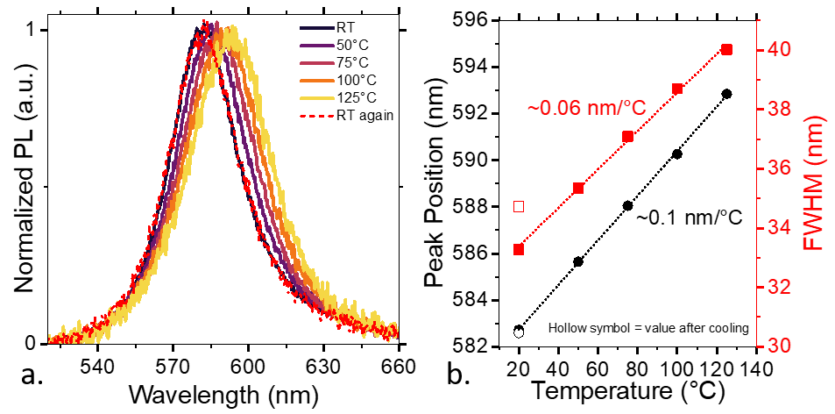
Figure S 7 Thermal dependence of the PL. a. PL spectra for the CdS/CdSe/CdS/CdZnS C-C-C-S NPLs under various temperatures. Absence of irreversible damage upon annealing is illustrated by overlap of the PL spectrum after cooling with initial spectrum. b. Peak wavelength and full width at half maximum as a function of annealing temperature.

REFERENCES
(1) Dai, X.; Zhang, Z.; Jin, Y.; Niu, Y.; Cao, H.; Liang, X.; Chen, L.; Wang, J.; Peng, X. Nature 2014, 515, 96–99.
(2) Qu, J.; Rastogi, P.; Gréboval, C.; Livache, C.; Dufour, M.; Chu, A.; Chee, S.-S.; Ramade, J.; Xu, X. Z.; Ithurria, S.; Lhuillier, E. ACS Appl. Mater. Interfaces 2020, 12, 22058–22065.

