Appendices
Appendix 1. Supplementary data analysis
Appendix 2. The European dairy sector

Appendix 1. Supplementary data analysis
Table A1. The relationship between number of cows, the total Costs and the total Revenues in EU countries (2008-2018)
Table A2. The relationship between number of cows and the Imputed family Labour Costs in EU countries (2008-2018)
Table A3. The relationship between number of cows and Family Labour (%) in EU countries (2008-2018)
Taula A4. The relationship between number of cows and the balance of subsidies and taxes in EU countries (2008 – 2018)
Table A5. Correlation matrix to the main variables regional level 2018 (118 regions)
Figure B1. The relationship between number of cows and Imputed Family Labour costs in EU countries (2008 – 2018)
Figure B2. The relationship between number of cows and Family Labour (%) in EU countries (2008 – 2018)
Figure B3. The relationship between number of cows and the balance of subsidies and taxes in EU countries (2008 – 2018)

Table A1: The relationship between number of cows, the total Costs and the total Revenues in EU countries (2008-2018)
EU countries 25 (2008-2018) | (1)Total Revenues | (2)Total Costs
 | Fixed Effects | Fixed Effects
Constant | -83463.23** | -102400.4***
 | (33832.70) | (21070.43)
Dairy Cows | 3830*** | 4284.827***
 | (526.3) | (332.42)
Prob>F | 0.00 | 0.00
Overall R-squared | 0.87 | 0.93
Within R-squared | 0.70 | 0.83
p_value (Hausman test) | 0.00 | 0.00
p_value (LM test) | 0.00 | 0.00

. Driscoll-Kraay standard errors are shown in parentheses. Stars correspond to the p-value: *for p < 0.10.**for p < 0.05. and***for p < 0.01. The Hausman and LM Tests indicate which is the most efficient model. All panels are cointegrated.
Source: authors’ own work based on FADN data
Table A2: The relationship between number of cows and the Imputed family Labour Costs in EU countries (2008-2018)
EU countries 25 (2008-2018) | Imputed family Labour Costs  (in euros)
 | Random Effects
Constant | 18548.31**
 | (7236.7)
Dairy Cows | 118.73**
 | (526.3)
Prob>F | 0.00
Overall R-squared | 0.12
Within R-squared | 0.12
p_value (Hausman test) | 0.95
p_value (LM test) | 0.00

Driscoll-Kraay standard errors are shown in parentheses. Stars correspond to the p-value: *for p < 0.10.**for p < 0.05. and***for p < 0.01. The Hausman and LM Tests indicate which is the most efficient model. All panels are cointegrated.
Source: authors’ own work based on FADN data

Table A3. The relationship between number of cows and the Family Labour (%) in EU countries (2008-2018)
EU countries 25 (2008-2018) | Family Labour(%)
 | Fixed Effects
Constant | 82.010***
 | (1.7)
Dairy Cows | -0.187***
 | (0.22)
Prob>F | 0.00
Overall R-squared | 0.48
Within R-squared | 0.40
p_value (Hausman test) | 0.00
p_value (LM test) | 0.00

Driscoll-Kraay standard errors are shown in parentheses. Stars correspond to the p-value: *for p < 0.10.**for p < 0.05. and***for p < 0.01. The Hausman and LM Tests indicate which is the most efficient model. All panels are cointegrated.
Source: authors’ own work based on FADN data
Taula A4. The relationship between number of cows and the balance of subsidies and taxes in EU countries (2008 – 2018)
EU countries 25 (2008-2018) | The balance of subsidies and taxes  (in euros)
 | Random Effects
Constant | -19191.18
 | (19244)
Dairy Cows | 1128.18***
 | (138)
Prob>F | 0.00
Overall R-squared | 0.61
Within R-squared | 0.41
p_value (Hausman test) | 0.85
p_value (LM test) | 0.00

Driscoll-Kraay standard errors are shown in parentheses. Stars correspond to the p-value: *for p < 0.10.**for p < 0.05. and***for p < 0.01. The Hausman and LM Tests indicate which is the most efficient model. All panels are cointegrated.
Source: authors’ own work based on FADN data

Table A5. Correlation matrix to the main variables regional level 2018 (118 regions)
 | Dairy cows | Total labour  ( AWU ) | Share of family labour  ( % ) | Milk yield  ( kg/cow ) | Milk production  ( t ) | Machinery and building upkeep | Energy (fuel, electricity) | Net margin | Imputed family factors | Net economic margin | Farm net income per AWU | Farm net income
Dairy cows | 1
Total labour  ( AWU ) | ,775** | 1
Share of family labour  ( % ) | -,780** | -,777** | 1
Milk yield  ( kg/cow ) | ,530** | ,275** | -,372** | 1
Milk production  ( t ) | ,990** | ,763** | -,776** | ,579** | 1
Machinery and building upkeep | ,315** | ,258** | -,242** | ,522** | ,338** | 1
Energy (fuel, electricity) | -0,054 | ,263** | -0,086 | -,250** | -0,050 | ,235* | 1
Net margin | -0,136 | -0,021 | 0,103 | -0,041 | -0,175 | -0,037 | -0,018 | 1
Imputed family factors | ,382** | -0,041 | -0,049 | ,598** | ,378** | ,433** | -0,157 | 0,084 | 1
Net economic margin | -,795** | -,848** | ,720** | -,421** | -,821** | -,528** | -,291** | ,211* | -,183* | 1
Farm net income per AWU | -,220* | -0,050 | 0,156 | -0,141 | -,214* | -,237** | ,190* | ,207* | -0,174 | 0,178 | 1
Farm net income(FNI) | ,429** | ,711** | -,526** | 0,147 | ,426** | ,186* | ,257** | ,237** | -0,124 | -,532** | ,407** | 1

Stars correspond to the p-value:.*for p < 0.05. and**for p < 0.01.
Source: authors’ own work based on FADN data

Figure B1. The relationship between number of cows and Imputed Family Labour costs in EU countries (2008 – 2018)
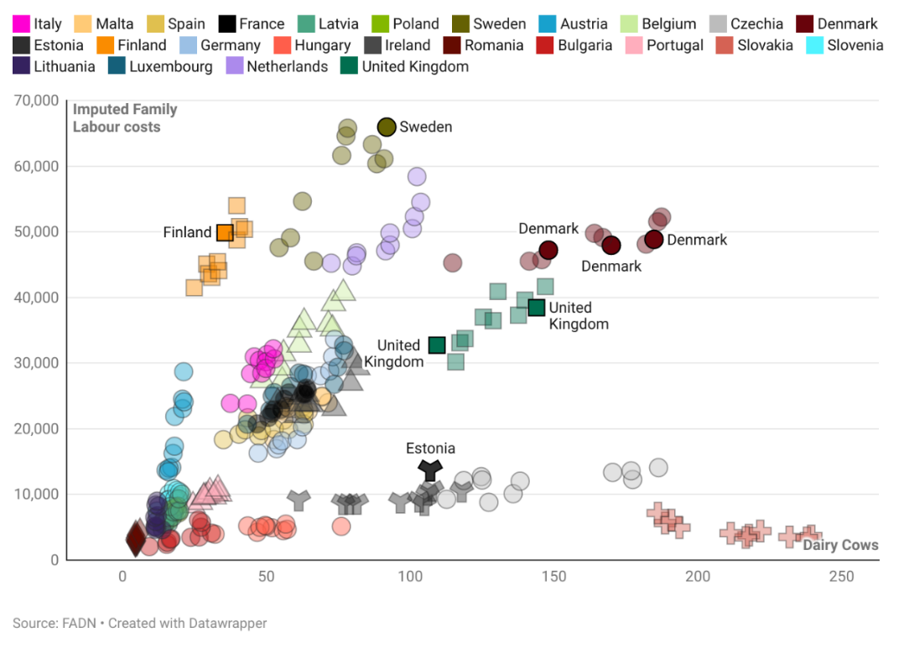
Source: authors’ own work based on FADN data
Interactive view: https://datawrapper.dwcdn.net/cpfW4/1/
Figure B2. The relationship between the number of cows and Family Labour (%) in EU countries (2008 – 2018)
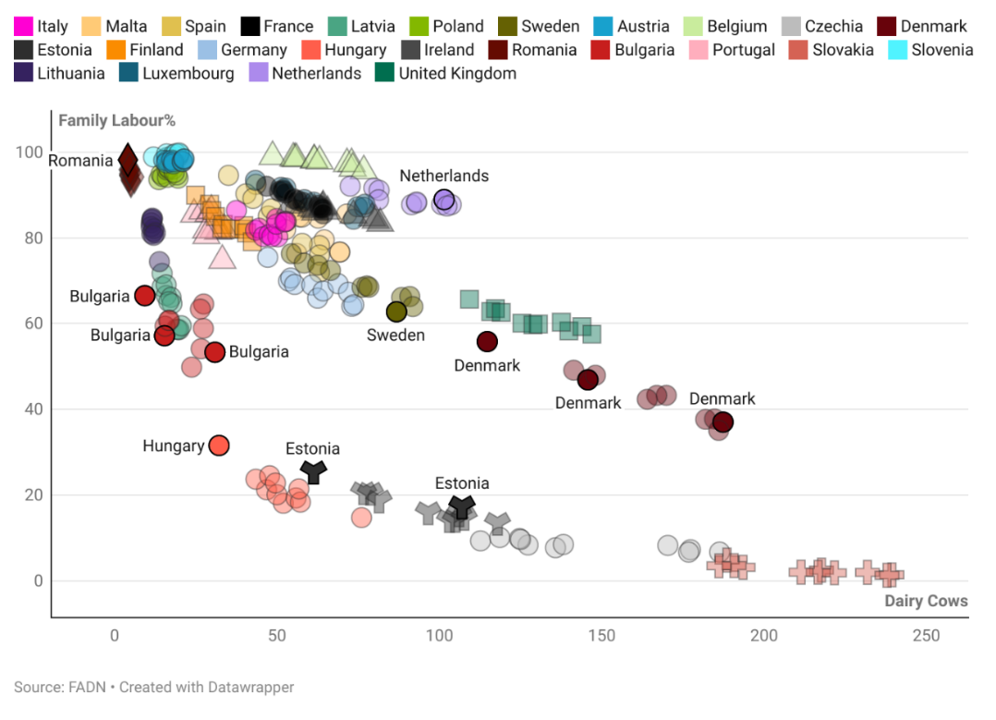
Source: authors’ own work based on FADN data
Interactive view:: https://www.datawrapper.de/_/w89mn/
Figure B3. The relationship between number of cows and the balance of subsidies and taxes in EU countries (2008 – 2018)
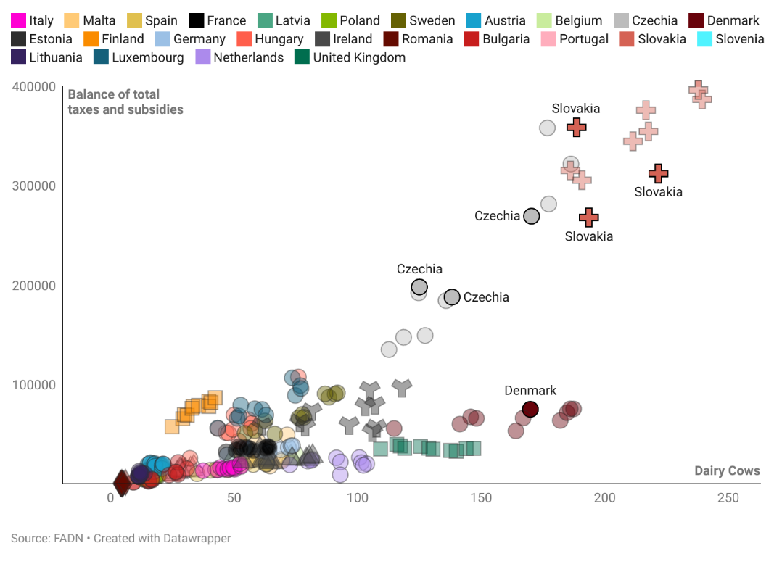
Source: authors’ own work based on FADN data
Interactive view: https://datawrapper.dwcdn.net/fj96k/2/

Appendix 2. The European dairy sector
According to Klikocka et al (2015) the European agricultural model is characterised by a close relationship with the economic and natural environment, utilising its own workforce and maintaining a relatively limited unit concentration. This model emphasises modern production practices that avoid overexploitation of natural resources and the environment, prioritising food production for local needs while gradually increasing export capacity. Additionally, the European agricultural model adheres to strict quality, environmental, and food safety standards. However, this model is not competitive with large-scale commercial farms commonly found in America, Australia, New Zealand, and the Republic of South Africa (RSA), and therefore requires financial support from public funds. Despite its economic functions, the European agricultural model also serves important public functions.
In concrete, the European Union dairy sector significantly contributes to the region’s agricultural output, accounting for over 12% of the total agricultural output. Milk production occurs in all EU Member States, albeit with varying farm and herd sizes, yields, and farming methods. For instance, while free-range farming is common in Alpine areas, large specialised dairy farms dominate in the northwest and centre of Europe. In 2016, dairies across the EU processed 157 million tonnes of raw milk into products such as butter and cheese (European Commission, 2018)
As part of the common agricultural policy, the EU's dairy policy employs a range of mechanisms to support farmers and address market imbalances, including common market organisation, public intervention and private storage provisions, direct payments, and rural development measures. The policy has undergone regular updates over time, with one significant development being the elimination of milk quotas in 2015.
The Common Agricultural Policy (CAP) reforms have significantly impacted milk prices in the European Union (EU) over the years. Three main stages have been identified in the historical evolution of milk prices. The first stage (1977-1992) was characterised by constant price growth and a guaranteed price system. Prices remained stable from 1992 to 2004. However, since then, the political environment surrounding the dairy industry has undergone significant changes under reforms implemented by the World Trade Organization (WTO) and the CAP. In the past, intervention buying, production quotas, export refunds, import tariffs and subsidised consumption measures helped to ensure higher and less volatile prices than those on the world markets. However, with lower levels of CAP support prices and reduced intervention, dairy commodity prices have become more volatile and closely aligned with world prices. O'Connor and Keane (2011) argue that the movement towards a more liberal global agricultural trading system has led to greater price volatility for dairy commodities, with prices fluctuating significantly since 2003.
Figure B4. Raw Milk prices EU 1977-2023

Source: Own figured based on data from the Milk Market Observatory
The volatility of milk prices in the EU has posed challenges for farmers, who have not historically faced such issues (O'Connor & Keane, 2009). Severe low and high price fluctuations can lead to financial problems such as reduced profit margins and difficulty obtaining financing (O'Connor, Bergmann, and Keane, 2015). The dairy industry is also affected by price volatility as businesses prefer stability to plan their customer relationships and transactions with more price-stable sectors. Moreover, replacing the CAP-guaranteed price system with three key instruments - decoupling of aid, eco-conditionality, and modulation of aid - has been detrimental to smaller farms while encouraging increased production. Decoupling agricultural aid to production was intended to end the incentive to over-produce food and reduce environmental pressure. The Direct Payments regulation established that “all payment entitlements in a Member State or in a region shall have a uniform unit value”, but it also details numerous derogations and technicalities in the process that, in practice, undermine achieving such uniform values.
Furthermore, the CAP aid is now linked to meeting specific non-productive criteria that align with citizens' post-productivist demands for food quality and environmental protection (eco-conditionality). However, applying these criteria increases production costs, as noted by the focus groups. Soler (2005) highlighted the impracticality of such aid in an environment where farms struggle to survive by increasing production, which harms the environment. The mandatory modulation of aid was introduced after a debate on aid distribution. Trade unions representing small and medium-sized farmers demanded social modulation of aid favouring small family farms. However, this modulation concept is not included in the 2003, 2009, and 2013 CAP reforms. In 2012, for instance, 16% of CAP beneficiaries received 75% of the aid, while the vast majority (84%) shared only 25%.
The path taken by dairy farmers the other EU countries, has followed a model of intensive industrial livestock farming fully incorporated within the global capitalist economy (Davidova & Thomson 2014). The changes introduced with the Common Agricultural Policy (CAP) in recent decades have resulted in a focus on maximizing dairy production efficiency in a liberalised, highly competitive, and productivist context. As a result, dairy farmers have tended to concentrate capital in larger farms, leading to a shift from a relatively large number of small and medium-sized farms to a smaller number of large, highly technical, specialised, and high-productivity farms (Clay et. al, 2020).
Although authors such as Bowler (1996) saw the CAP reforms as marking the beginning of a post-productivist model by incorporating the discourse of sustainability into agriculture, it has rather highlighted the contradictions facing the agrarian sectors, as we shall see in this article. These policies are part of the changes that have occurred in governance systems in recent decades, guided by what some authors have described as neoliberal technologies" (Busch 2010). The governance model developed between the EU Member States and other private organisations in the dairy sector shifted from partial regulatory measures to full liberalisation in 2015. EU Regulation 856/84 established a restriction system for milk production in member countries, understood as a corrective system to address market imbalances by imposing limits on annual milk production (milk quotas). The end of quotas in 2015 marked a turn towards a neoliberal project with new forms of governance, reducing states' roles to coordinators for the different parties involved in the governance of the milk sector (Little 2001). This new framework led to changes in the game’s rules for the different actors, including farmers, but rather than true deregulation, a re-regulation of relationships between actors was put in place (Polanyi 2015).
The Milk Package was introduced by the European Commission before the end of the quota policy, aimed at stabilising the dairy sector and preparing it for a market-driven environment. However, its effectiveness has been questioned due to the sector's lack of structure and diffuse distribution of power between different levels of public administration, as well as the unequal relations between the dairy industry and farmers under the new rules of the game (Clay et al., 2020). These rules have created a captive and hierarchical form of governance, where the industry and large distributors control the purchase and sale of milk by imposing certifications, accreditations, and supply chain controls (Busch, 2010). Although measures such as promoting contracts for the purchase and sale of milk between farmers and industry have been introduced to strengthen the negotiating position between the parties, in practice, the industry tends to benefit, thus perpetuating power imbalances (Santiso & Sineiro, 2020).
Different studies have shown how the dairy industry has an upper hand in the so-called "negotiation" for the sale and purchase of milk and the terms associated with the contract. This power imbalance has been identified as a reason for unjust business practices. Furthermore, the literature also highlights asymmetrical costs in executing contracts, asymmetrical information, clauses in the contracts or unilateral changes, and the increased number of milk sales on the free market (Dimarcoantonio, et. al 2020).
In general, the neoliberal governance can be seen as having enabled the dominant oligopsonistic structure of the milk market, giving the industry control over prices and influencing transactions with farmers (Čechura, et. al 2015). Thus, farmers are integrated into commercial channels by accepting certain conditions such as increased production, contracts, and the introduction of technology, transforming them into another link in the industrial chain. This has led to a disguised proletarianization process, in which the farmer becomes a de facto employee of the agro-industrial complex (Bernstein 2010). Furthermore, the obligation of farmers to acquire intensive industrial inputs at higher prices puts dairy farms at a disadvantage with respect to output buyers (the industry) and input providers who supply necessary inputs such as machinery and fuel (Falkowski et al. 2017).
In fact, European dairy farm holdings are witnessing a process of disappearance and concentration (Barbeta-Viñas & Requena-i-Mora, 2022). Firstly, we observed an increase in milk production, despite the decrease in the number of cows. This is evidence of an increase in milk productivity per cow. However, we noted that modernising production effectively contributed to hindering the growth in the number of dairy farms. We saw that there was a decrease in the number of cattle, an increase in production and productivity, but a dramatic decrease in the number of farms. We saw, therefore, a process of concentration.
Figure B5. Evolution of the number of farms, cows, and milk production in the EU. (Index: 100 = 2003)
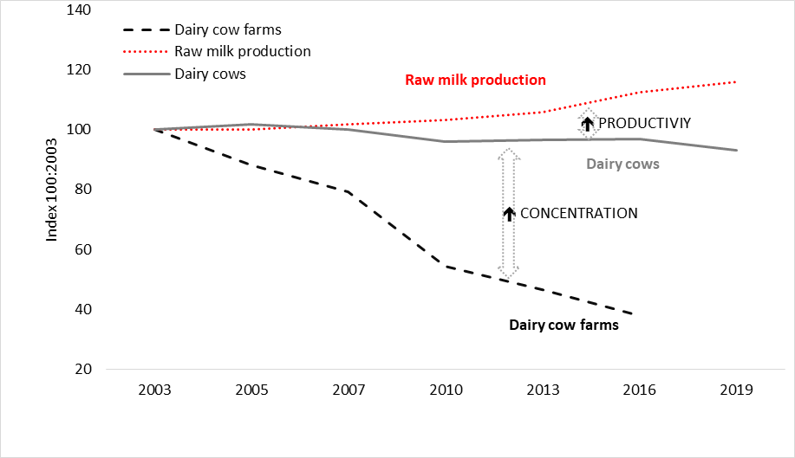
Source: authors’ own work based on Eurostat data
The structure and distribution of farms according to the number of cows was very dualistic. The EU was characterised by a network of small farms - in 2016, farms with 1 or 2 cows accounted for almost 35% of the total - and at the same time, there were also medium and large farms with more than 100 cows - 12.9% - but which accounted for almost 70% of the total number of dairy cattle in the EU. To get a more accurate picture of the distribution of farms and herds, Gini coefficients were calculated (Table A6) and the corresponding Lorenz curves were drawn for the EU as a whole (Figure 5).
Table A6. Holdings by strata, cumulative percentages and Gini coefficient
 | Holdings | Dairy cows | Accumulation of holdings % | Accumulation of dairy cows %
1 - 2 | 421,100 | 523,800 | 34.8 | 6.2
10 - 19 | 102,560 | 689,140 | 43.2 | 8.2
20 - 29 | 62,620 | 758,790 | 48.4 | 9.5
3 - 9 | 296,940 | 814,280 | 72.9 | 16.4
30 - 49 | 76,480 | 1,445,960 | 79.2 | 19.5
50 - 99 | 94,800 | 3,239,520 | 87.1 | 28.1
GE100 | 156,670 | 16,291,890 | 100 | 100
 | 1,211,170 | 2,376,3380 | Gini coefficient 0.8
Source: authors’ own work based on Eurostat data
The Lorenz curves clearly showed an unequal distribution [of farms and cows] in the European Union. There were countries with very equal distributions, with a Gini coefficient close to 0, such as Romania, and countries with more unequal distributions than the EU as a whole, like Germany, with a Gini coefficient of 0.9.
Figure B6. Lorenz curves of farms and cows in the EU, Romania, and Germany (2016)
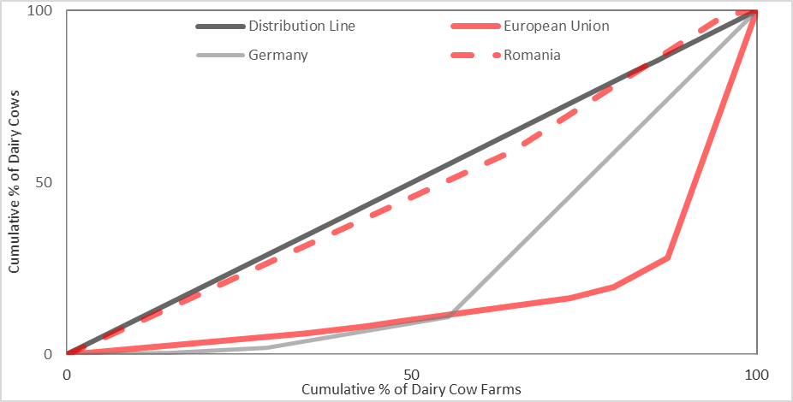
Source: authors’ own work based on Eurostat data
Despite the very different distribution among EU countries, we observed that the trend towards the concentration of the number of cows in large farms increased year on year, with the most abrupt change in the last year studied, 2016, the year after quotas were abolished. Farms with more than 100 cows grew by 10%. And the number of cows in these farms increased by around 33%.
Figure B7.1. Evolution of the percentage of holdings
Figure B7.2. Evolution of the number of cows (2005 - 2016)
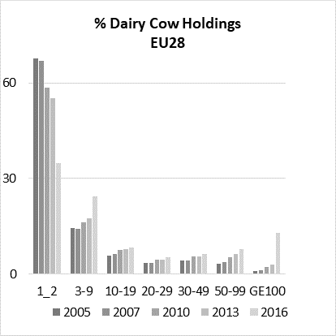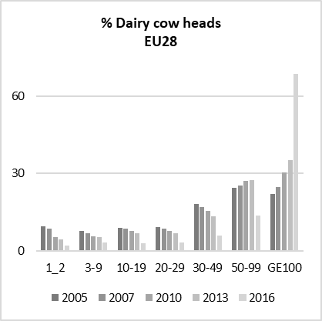
Source: authors’ own work based on Eurostat data
In Figures B7.1 and B7.2, we observed two parallel trends that show what was happening to farms in the dairy sector very well. There were fewer and fewer farms in the EU. And the remaining farms were larger. Moreover, these two graphs can be interpreted in light of the social paradox of modern agriculture (Ortí, 1997): the modernisation of production has contributed to the abandoning of small, traditional, family dairy farming.
References
Barbeta‐Viñas, M., & Requena‐i‐Mora, M. (2022). The paradoxes of dairy farmers in Catalonia (Spain): Crisis and ‘double bind’. Sociologia Ruralis, 62(1), 91-111.
Berstein, Henry. 2010. Class dynamics of agrarian change. Nova Scotia: Fernwood Publishing
Busch, Lawrence 2010. "Can Fairy Tales Come True? The Surprising Story of Neoliberalism and World Agriculture". Sociologia Ruralis, 50(4):331-351.
Čechura, Lucas, Žáková Kroupová, Zenka, and Hockmann, Heinrich. 2015. “Market Power in the European Dairy Industry”.AGRIS on-line Papers in Economics and Informatics 7: 39-47.
Clay, Nathan, Garnett, Tara, and Lorimer, Jamie. 2020. "Dairy intensification: Drivers, impacts and alternatives". Ambio 49: 35–48.
Davidova, Sophia and Thomson, Kenneth. 2014. Family Farming in Europe: Challenges and prospects. Brussels: European Union.
Di Marcantonio, Frederica, Ciaian, Pavel and Falkowski, Jan. 2020. “Contracting and Farmers’ Perception of Unfair Trading Practices in the EU Dairy Sector”. Journal of Agricultural Economics 71(3):877-903.
European Commission (2018) The EU dairy sector Main features, challenges and prospects. Available in: https://www.europarl.europa.eu/RegData/etudes/BRIE/2018/630345/EPRS_BRI(2018)630345_EN.pdf
O’Connor, Declan and Keane, Michael. 2009. Price Volatility in the EU Dairy Industry: Causes, Consequences and Coping Mechanisms. Brusseles: European Dairy Association.
O’Connor, Declan and Keane, Michael. 2011. “Empirical issues relating to dairy commodity price volatility”. Pp. 63-83 in:Methods to analyse agricultural commodity price volatility, edited by Piot-Lepetit, I. and R. M’Barek,. NY: Springer.
O’Connor, Declan; Bergmann, Dennis and Keane, Michael. 2015. “The challenges posed by price volatility in the EU dairy sector”. Prague: Conference: Agrarian Perspectives XXIV and 25th Annual Conference of the Austrian Society of Agricultural Economics.
Ortí, Alfonso. 1997. “Una visión histórica generalista de la sociología agraria en España: las tres modernizaciones del desarrollo capitalista”. Pp. 71-108 in: Agricultura y sociedad en la España contemporánea, edited by González, J. J. and Gómez, C., Madrid: CIS.
Polanyi, Karl 2015. “La economía como actividad institucionalizada”. Revista de Economía Crítica, 20: 192-207.
Santiso, Jorge and Sineiro, Francisco. 2020. “La negociación de los contratos y las organizaciones de productores en el sector lácteo”. Agronegocios, 740. Available at: www.agronegocios.es
Soler, Marta 2005. La Política Agraria de La Unión Europea. Ecologistas en Acción: http://www.ecologistasenaccion.org/article1347.html

